Projects – Software/Website Documentation
Code-Ninja Portfolio Website
URL – https://github.com/XDENTERTAINMENT/NinjaPortfolio

Prepared by – Njeze Peter Nnabuike (Code-Ninja)

Project – Software/Website Documentation
Pagination
Number of sections on Landing Page – 7 (Hero, About Me, My Skills, My Projects, Projects Showcase, Get In Touch, Footer)
Number of navigation links – 6 (Home, About, Skills, Projects, Video-Card, Contact)
Number of individual project case studies – 3 (MamaPut, Personal Portfolio, PayPoint)
Number of showcased media items – 6 (E-book, Podcast, Blog, Mamaput)
Technology
Frontend – HTML5, CSS3, Responsive Design, UI/UX, Tailwind CSS (JavaScript currently being learned)
Tools – Git, GitHub, VS Code, Figma, Chrome DevTools, Command Line
Other – Problem Solving, Agile Workflow, Code Review, Technical Writing
Application Type
Single-page personal portfolio website (one-page scrolling site with anchor navigation)
Included
• Screenshots
• Description & Overviews
• Workflows
• Other Details
PURPOSE OF DOCUMENT
1. Version Management
2. Technical Support
3. Functional Spec Team
4. Programming Team
5. Intellectual Property Filing
6. Trade Mark Purposes
7. Copyright Purposes
8. Other Miscellaneous Purposes
1.0 LANDING PAGE
This is a single scrolling landing page divided into the following major sections:
• Navigation Menu
• Hero Section
• About Me Section
• My Skills Section
• My Projects Section
• Projects Showcase Section (Video/Media Section)
• Get In Touch Section
• Footer
SCREENSHOT OF THE LANDING/HOME PAGE

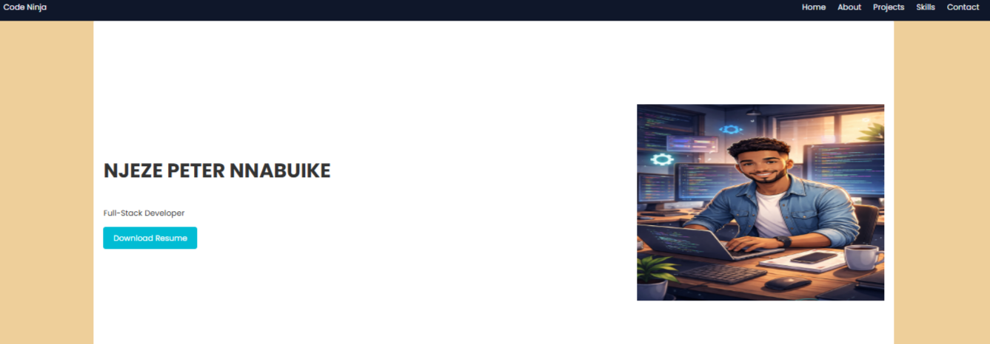
1.1 NAVIGATION MENU SECTION
Overview
This section sits at the very top of the landing page and occupies 100% of the page width. It is captured in a dark navy frame with no borders. At the extreme left-hand corner is the corporate wordmark “Code-Ninja”, and towards the extreme right there are six clickable navigation links.
Comments
• This section sits on top of the landing page and remains visible as the primary way-finding element of the site.
• The brand name is split into two colors – “Code” in white and “-Ninja” in white – to reinforce the developer identity.
• Each navigation label (Home, About, Skills, Projects,Contact) is an anchor link that scrolls the visitor to the matching section further down the same page, rather than opening a separate page.
• The links are evenly spaced and right-aligned, keeping the logo as the sole element on the left.

1.2 HERO SECTION
Overview
The hero section is the first content area a visitor sees below the navigation menu. It introduces Mary Ann, states her professional title, gives a short summary of her focus areas, and offers two call-to-action buttons alongside a circular profile photograph.

Comments
• The subtitle “Full-Stack Developer” identifies her role directly beneath her name.
• A three-line summary paragraph explains her focus on responsive, modern web applications built with HTML, CSS, JavaScript, and related technologies.
• One buttons are provided: a solid blue “Download CV” button
• On the right-hand side, a professional headshot is displayed inside a Square frame, balancing the text content on the left.

2.0 ABOUT ME SECTION
Overview
The About Me section sits on a light-grey background to visually separate it from the hero section above. It pairs a photograph of Mary Ann working with a laptop against a heading and two paragraphs of narrative text.

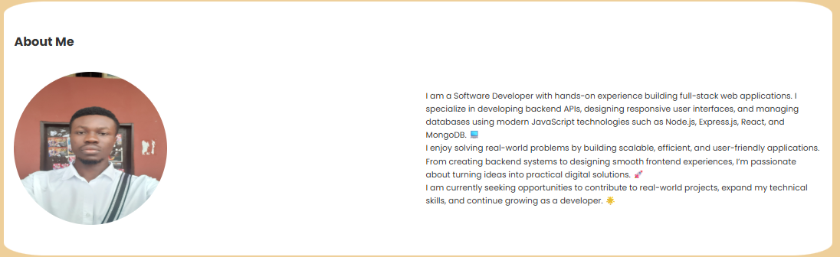

Comments
• 2.1The image on the left shows Njeze taking a selfie.
• 2.2The heading “About Me” is bold and left-aligned above the image.
•2.3 The text on the right,the first paragraph introduces him as a Software Developer with hands on experience in building full-stack applications.
•2.4 The second paragraph talks about how is loves solving real world problem by building scalable, efficient, and user-friendly applications. From creating backend systems to designing smooth frontend experiences,
•2.5 The third paragraph talks about seeking opportunities to contribute to real-world project

3.0 MY SKILLS SECTION
Overview
This section is titled “My Skills” and presents eight equal-width cards on a white background, each grouping a related skills with a small icon illustrating the skill above them.
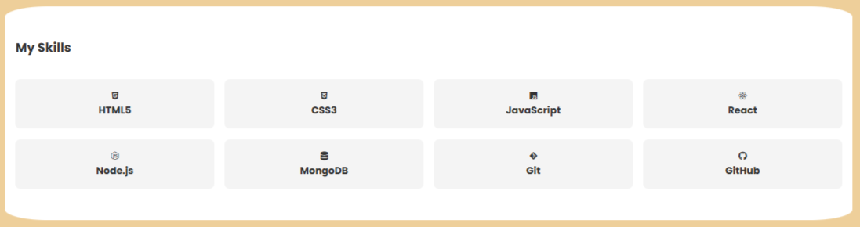
Comments
• Card 3.1 “Html5”,
• Card 3.2 “Css3”,
• Card 3.3 “JavaScript”,
• Card 3.4 “React”,
• Card 3.3 “Node.js”,
• Card 3.3 “Mongo dB”,
• Card 3.3 “Git”,
• Card 3.3 “GitHub”,

• Each card uses a light grey card background with a small colored icon above the skill title, giving the section a clean, scannable layout.

4.0 MY PROJECTS SECTION
Overview
Titled “My Projects”,this section presents three case-study cards, each displaying projects I have done ending with a “Live Demo”, “GitHub repo” button.
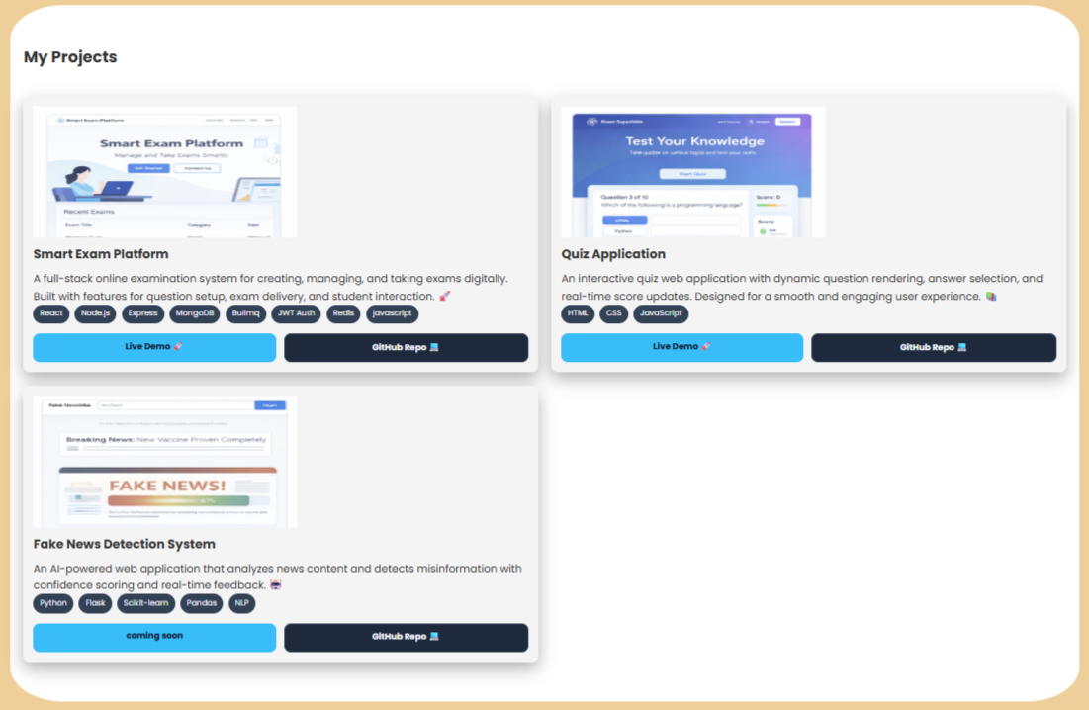

4.1 Card1 (Smart Exam Platform)

4.1.1 Has two divs, one containing the image illustration overview of the project placed above the second div.
4.1.2 The second div contains a header “Smart Exam Platform” and a subtitle “ talking about the platform”.
4.1.3 listed all the stacks used right beneath the subtitle eg react,node.js,Express,Mongodb,Bullmq,JWT Auth,Redis and Javascript all placed in a div with background color of linear gradient #34444c.
4.1.4 Live Demo – A blue “Live Demo” and “Github repo” button links out to the deployed site.

4.2 Card2 (Quiz Application)

4.2.1 Has two divs, one containing the image illustration overview of the project placed above the second div.
4.2.2 The second div contains a header “Quiz Application” and a subtitle “ talking about the platform”.
4.2.3 all the stacks used right beneath the subtitle eg Html5,CSS3, and Javascript all placed in a div with background color of linear gradient #34444c
4.2.4 Live Demo – A blue “Live Demo” and “Github repo” button links out to the deployed site.

4.3 Card3 (Fake News Detection System)

4.3.1 Has two divs, one containing the image illustration overview of the project placed above the second div.
4.3.2 The second div contains a header “Fake News Detection System” and a subtitle “ talking about the platform”.
4.3 3 all the stacks used right beneath the subtitle eg python, flask, scikit-learn, panda, NLP all placed in a div with background color of linear gradient #34444c
4.3.4 Live Demo – A blue “Live Demo” and “Github repo” button links out to the deployed site.

5.0 PROJECTS SHOWCASE SECTION
Overview
Titled “Projects videos Showcase” with the subtitle “A Video Section showing the Projects that I have Built,” this section presents six media cards arranged in a two-row, three-column grid. Each card contains an embedded video player thumbnail, a title, a short description, and a call-to-action button/link.

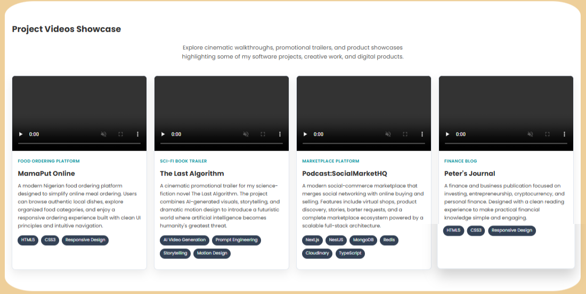

5.1 E-book Project

• A practical guide discussing building healthy, lasting relationships through love, wisdom, trust, and intentional choices.
5.2 Tech & Career Podcast

• A podcast discussing about socialmarkethq a social e-commerce platform for connecting people

5.3 Finance Blog

• A blog that empowers Africans with insights on AI, programming, remote work, business, and innovation to prepare for the future of work.
5.4 UBA Sentiment Analysis

• An analysis exploring customer sentiments and emotions expressed in UBA bank reviews, revealing key strengths, customer concerns, and insights to support better decisions and brand growth.

6.0 contact me section
Overview
This closing section invites visitors to make contact to me,and a call-to-action button, and a row of social profile links.
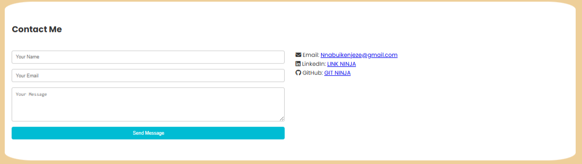
Comments
6.1 Heading “contact me” with a description stating she is open to new opportunities, questions, project discussions, or joining a team.
6.2 A contact form for name, Email and text message
6.3 Below the button, three text links – GITHUB, LINKEDIN, and TIKTOK – provide direct paths to her social and professional profiles.

7.0 FOOTER
Overview
The footer is a full-width dark navy bar that closes out the page, mirroring the color of the navigation menu at the top and giving the single-page site a bookended appearance.
Comments
7.1 The brand wordmark “Njeze Peter Nnabuike” repeats on the left, matching the navigation menu styling.
7.2 Centered copyright text reads “© 2026 Njeze Peter Nnabuike. All rights reserved.”
.

DEWEY NUMBERING – SECTION OUTLINE
Projects – Software/Website Documentation
URL – https://github.com/XDENTERTAINMENT/NinjaPortfolio
Number of major sections – 7

1.0 Home / Hero Section
2.0 About Me Section
3.0 My Skills Section
4.0 My Projects Section
5.0 Projects Showcase Section
6.0 Contact me
7.0 Footer

SUB-SECTION BREAKDOWN
Home / Landing Page – Sub Sections
• Comment 1 – The navigation menu sits on top of the landing page and remains visible for the entire single-page scrolling experience.
• Comment 2 – Unlike a multi-page site, all numbered sections below live on one continuous page and are reached via anchor links or scrolling.
• Comment 3 – The corporate logo sits on the left-hand top corner while the remaining navigation items sit on the right-hand side.
• Comment 4 – Apart from the logo, each navigation item is clickable and scrolls the visitor to its corresponding section.

1.1 Navigation Menu
1.1.1 Corporate Logo (Code-Ninja)
1.1.2 Home Link
1.1.3 About Link
1.1.4 Skills Link
1.1.5 Projects Link
1.1.6 Video-Card Link
1.1.7 Contact Link
1.2 Hero Introduction
1.2.1 Greeting & Name
1.2.2 Role / Title
1.2.3 Summary Paragraph
1.2.4 Call-to-Action Buttons (Download CV)
1.2.5 Profile Photograph
2.1 Section Image
2.2 About Me Narrative
3.1 Full-stack Skills Card
3.2 Tools Skills Card
3.3 Other Skills Card
4.1 Smart Exam Platform
4.1.1 Problem
4.1.2 Design Process
4.1.3 Development
4.1.4 Outcome
4.1.5 Live Demo Link
4.2 Quiz Application
4.2.1 Problem
4.2.2 Design Process
4.2.3 Development
4.2.4 Outcome
4.2.5 Live Demo Link
4.3 Fake new Detection system
4.3.1 Problem
4.3.2 Design Process
4.3.3 Development
4.3.4 Outcome
4.3.5 Live Demo Link
5.1 E-book Project
5.2 Tech & Career Podcast
5.3 FinanceBlog
5.4 UBA Sentiment Analysis
6.1 Contact Heading & Description
6.2 Contact form
6.2 Social Links (GitHub, LinkedIn, Email)
7.1 Brand Name (Njeze Peter Nnabuike)
7.2 Copyright Notice
7.3 Social Icons

